**ycFeedbackA3**

**Home Page**

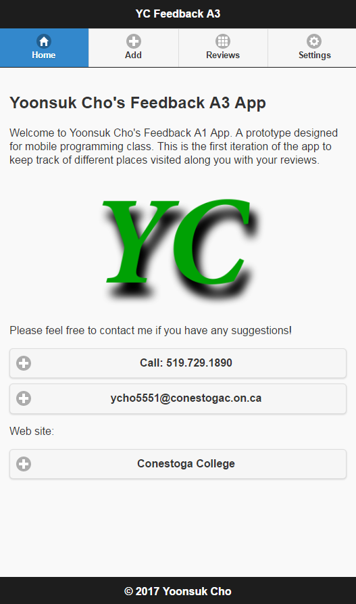

**Add a Feedback page with data with checkbox unchecked and with Alert (Successfully inserted)**

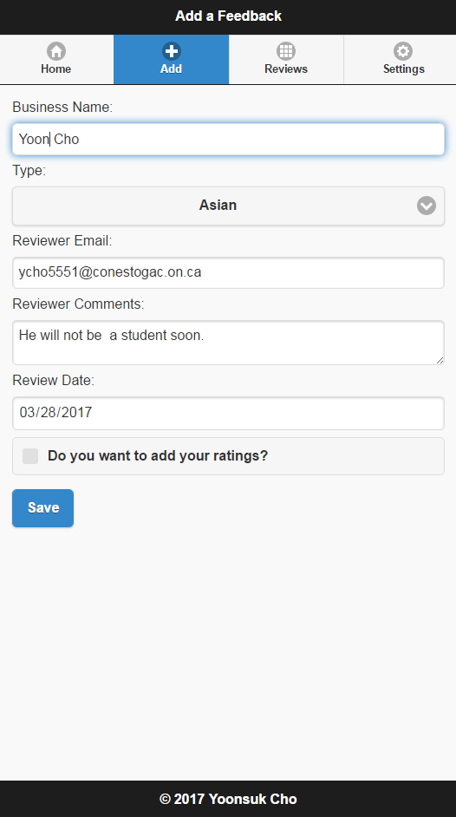

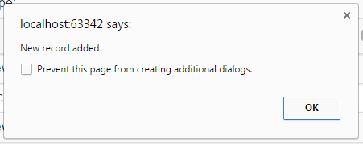

**Add a Feedback page with data with checkbox checked and with Alert (Successfully inserted)**

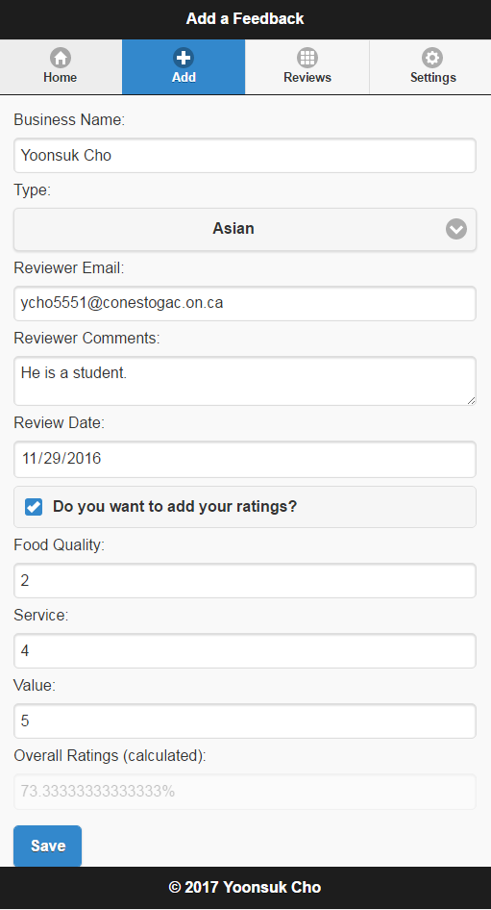

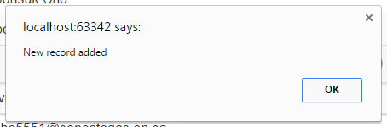

**Screenshot of Developers tools showing 2 records (1 with ratings, the other without ratings)**

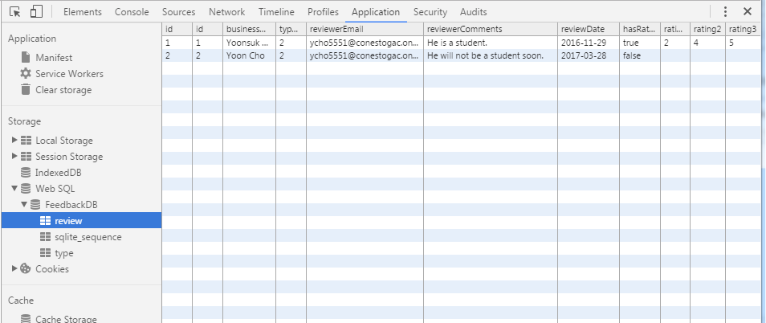

**Screenshot of Reviews page showing 2 items (previously inserted)**

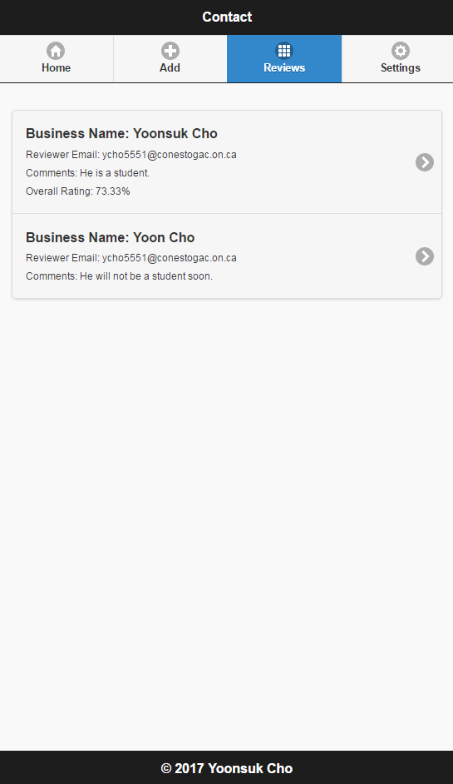

**Modify Feedback page with successfully updated Alert**

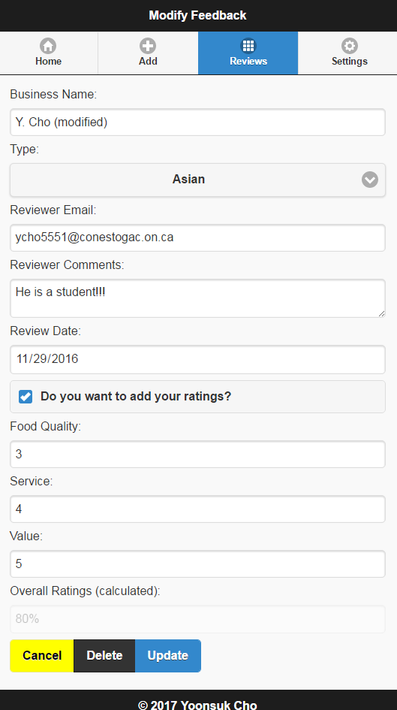

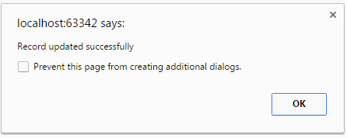

**Modify Feedback page with successfully delete Alert**

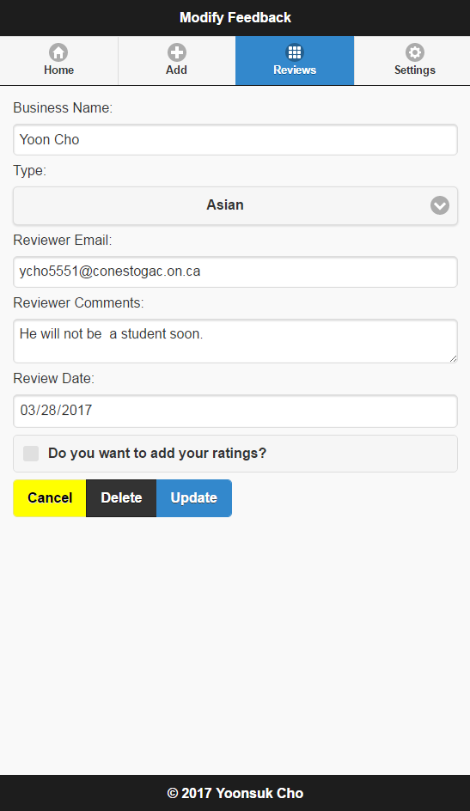

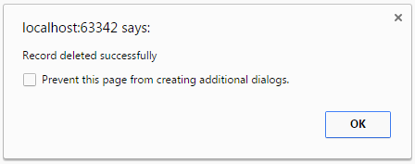

**Settings page with alert (after clearing database)**

